4.1.3- Number of classrooms and seminar halls with ICT-enabled facilities such as smart class, LMS, etc.
College has facilitated with 54 (Fifty-four) number of class rooms, 11 (Eleven) number of Halls with 03 (Three) number of Smart Class Rooms altogether with newly constructed science building and the main structure of the college.
Halls:
There are 11 halls in college 06 are in main building and 05 are in newly constructed Science Building. A sample of a hall is provided in picture below.
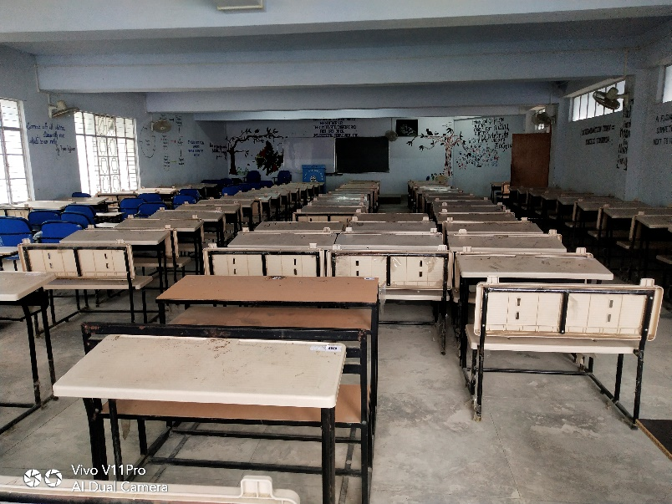

Sample of Hall

Class Rooms:
27 small size class rooms are available in the main building of the college and 10 are in Science Building.

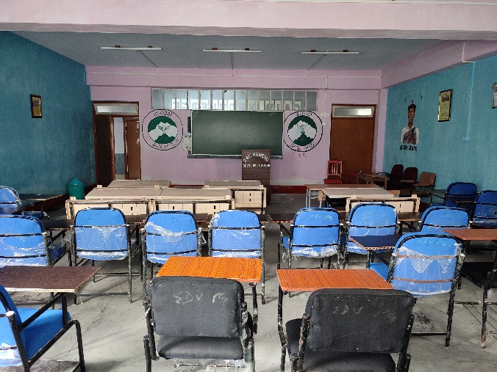

Small size class room

Smart Class Rooms:
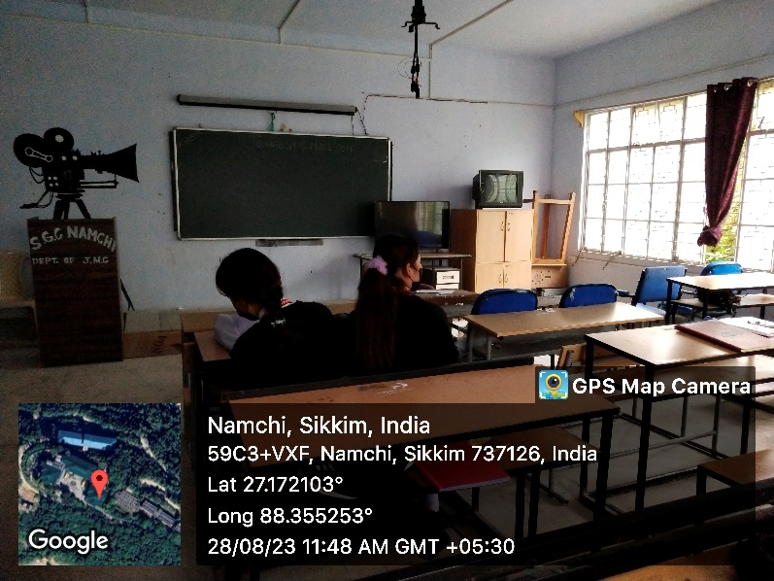
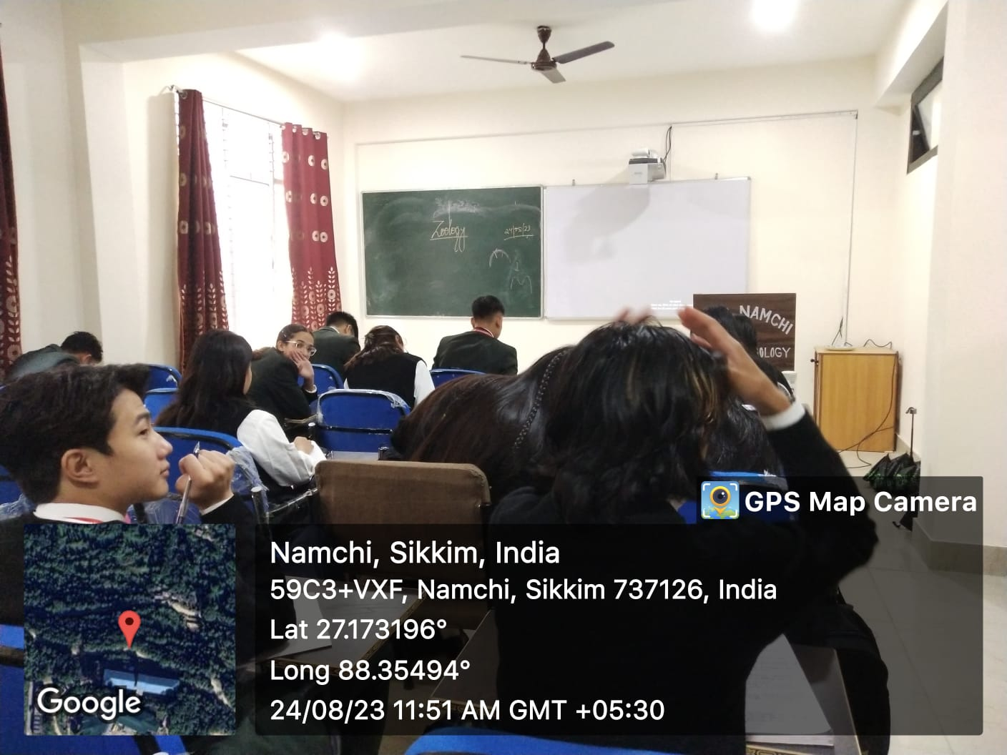
College has equipped with 03 smart class rooms, for the Department of Zoology, and Geography is provided with 01 each and another is associated with EDUSAT.
EDUSAT Room
Zoology Department

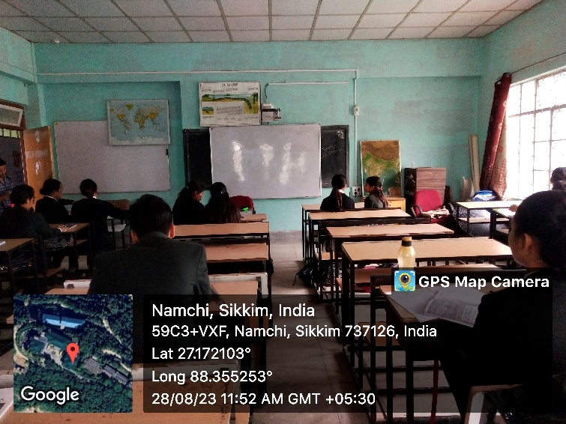

Geography Department

