SIKKIM GOVERNMENT COLLEGE, NAMCHI
SOUTH SIKKIM-737126

5.1.6 The institution has a transparent mechanism for timely reprisal of student grievances including cases of sexual harassment and anti-ragging.

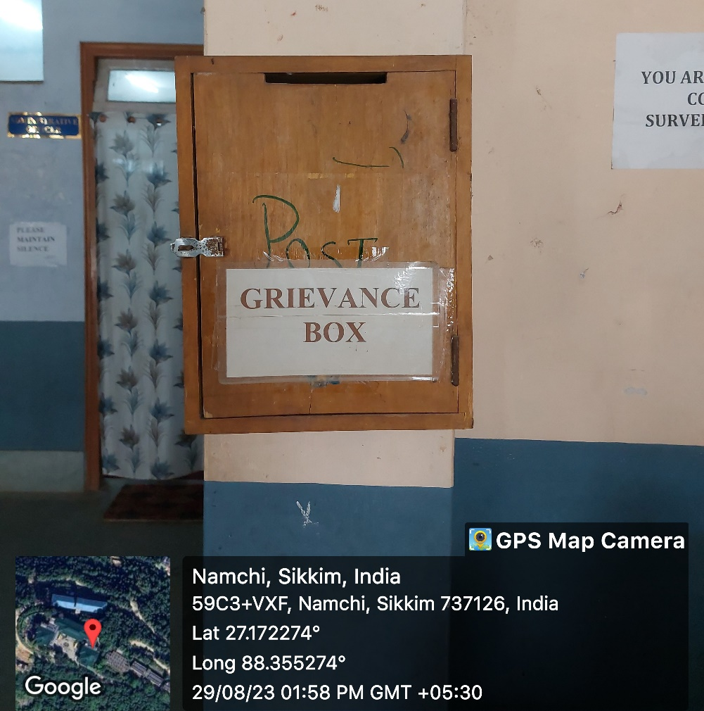
Fig: Grievances Complaint Box at College Entrance

SIKKIM GOVERNMENT COLLEGE, NAMCHI
SOUTH SIKKIM-737126

5.1.6
The institution has a transparent mechanism for timely reprisal of student grievances including cases of sexual harassment and anti-ragging. The college has a Grievance Redressal Committee to address the issues of the complainants.
The grievances of various natures comprising of academic related to examination, attendance, reassessment of result and non-academic related to harassment within the college premises etc are addressed by the committee.
The college also has its own anti-ragging committee which abides by the rules as per the UGC norms. The students submit an anti-ragging affidavit form mandatorily at the time of admission which conforms them to the rules and regulations of the institution.
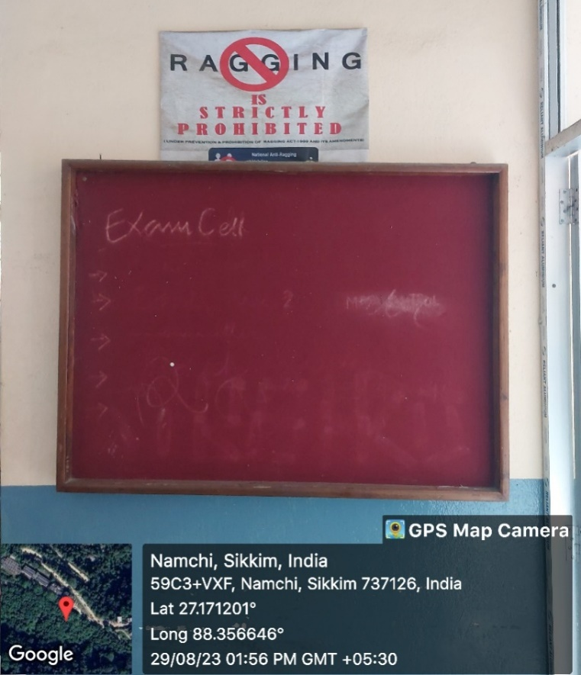
Fig: Anti-ragging board displayed on the wall of SGC Namchi

