SIKKIM GOVERNMENT COLLEGE, NAMCHI
SOUTH SIKKIM-737126

5.3.3 Number of sports and cultural events/competitions in which students of the Institution participated during the year (organized by the institutions/other institutions).

The college organized and participated in the following sports activities like Football, Table Tennis, Volleyball and Unity Run. The year-wise report is as follows-

INTER-DEPARTMENTAL FOOTBALL TOURNAMENT
SIKKIM GOVERNMENT COLLEGE, NAMCHI
(13th-24th April 2019)
The Department of Physical Education organized an inter-departmental football tournament in the college ground from 13thApril-24th April 2019. All together 19 departments from the college participated in the tournament. This kind of tournament inculcates an idea of unity and sportsmanship in the students.

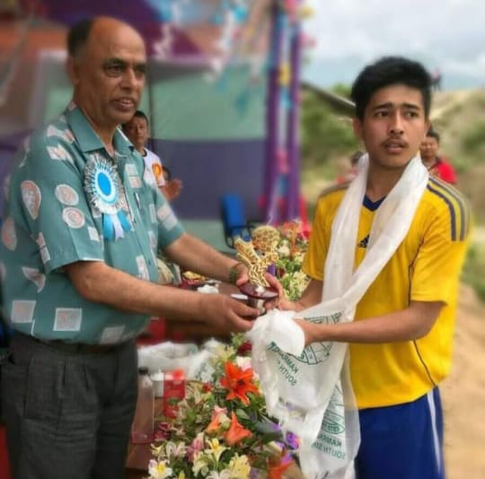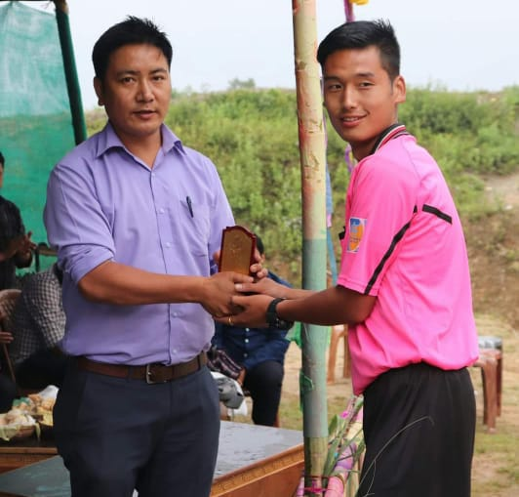
Figure 1: Mr. Tilak Chettri receiving Man of the Match Figure 2: Official of the match being felicitated.
Trophy from the Principal.

SIKKIM GOVERNMENT COLLEGE, NAMCHI
DEPARTMENT OF PHYSICAL EDUCATION
LATE ALEXIUS DHUNGEL MEMORIAL TABLE TENNIS CHAMPIONSHIP 2021
ORGANIZED BY SIKKIM TABLE TENNIS CLUB (STTC)
(17th Dec-19th Dec 2021)
Eight students from the college participated in the championship organized by STTC. This gave the students
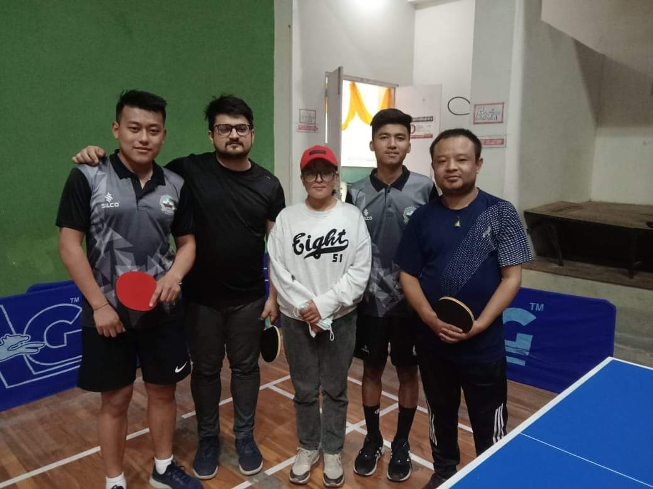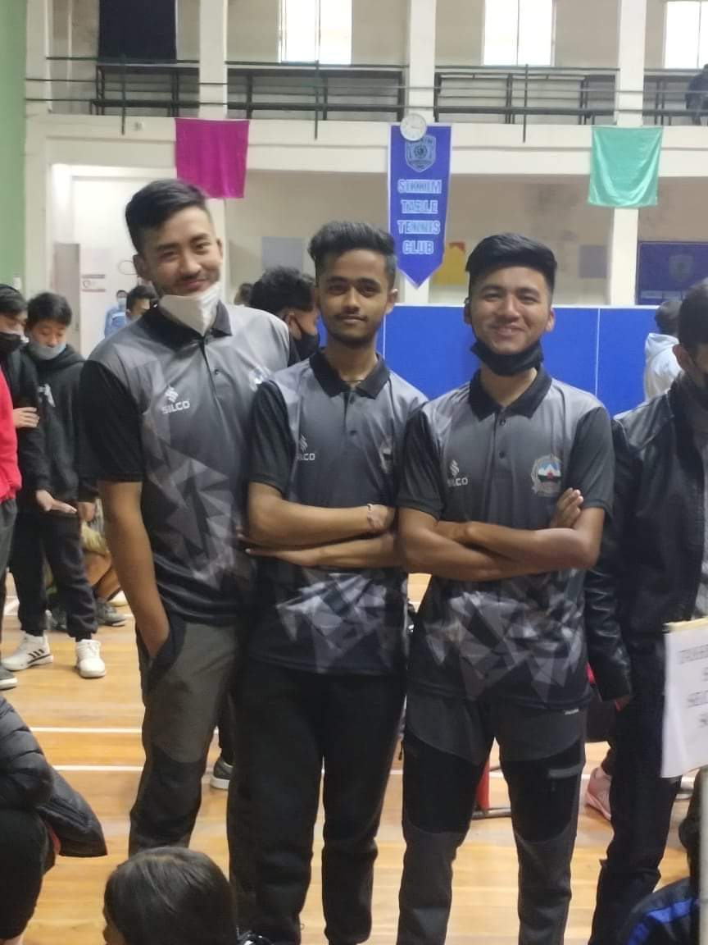
Figure: Mr. SherabBhutia, Mr. Asis Pradhan, Mr. NaradPokhrel and Mr. Ashish Chettri Representing SGC Namchi.

SIKKIM GOVERNMENT COLLEGE, NAMCHI
DEPARTMENT OF PHYSICAL EDUCATION
Organized two weeks inter-departmental football tournament (Boys/Girls)
7th-17th May 2022
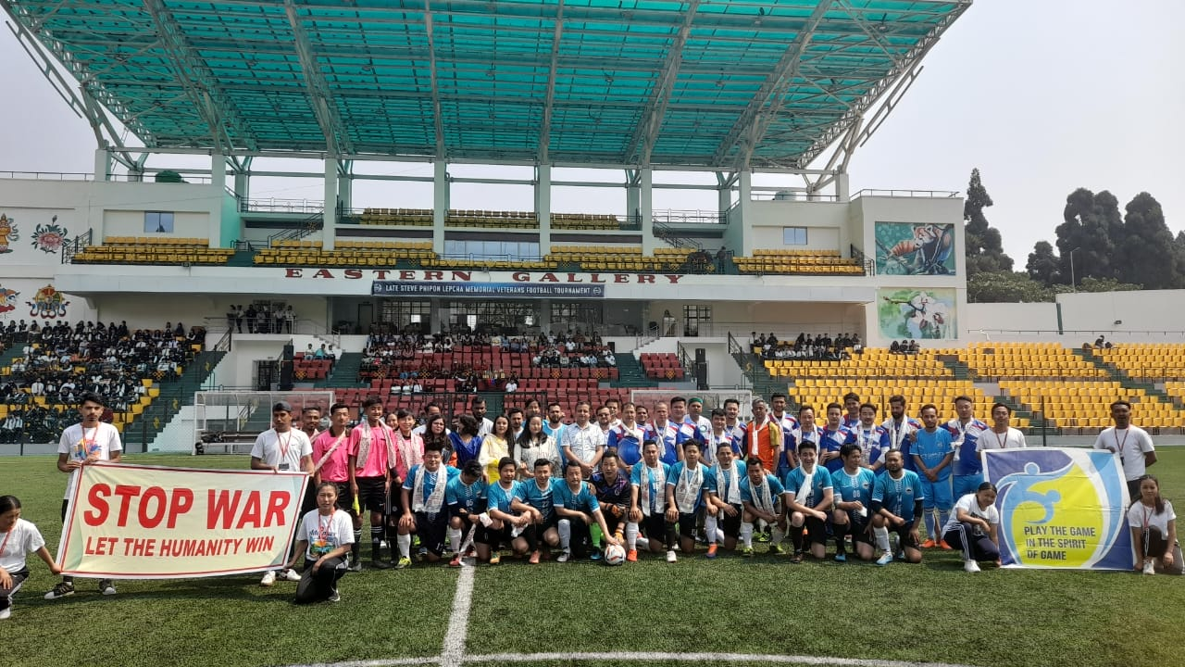
Figure 1: Exhibition Match: Chief Guest along with the team NBBDC Tadong and SGC, Namchi.
The department of physical education of SGC, Namchi organised two weeks inter-department football tournament. The tournament was organized under the theme “Stop War” and also emphasized on all round development of the students and to promote health awareness. All together 19 departments participated in the tournament.
Principal of the college Mr. Deepak Tewari and Vice Principal Mrs.Diki O. Lepcha encouraged the teams with their motivating words and witnessed the matches as the chief guests of the event. The college also invited faculties of NBBDC, Tadong for exhibition match against SGC, Namchi wherein SGC, Namchi won the match with the score of 3-2.
Under girls category, the tournament was won by Physical Education girls team and English department girls team stood as runner-up.
Department of Physical Education won the tournament under boys category, EVS Department being the runner-up.
The players were honoured with medals and certificates by Mr. Deepak Tewari, Principal and Mrs.DikiBhutia, Dean of the Students Affairs. The officials and the coaches were also felicitated with mementoes.

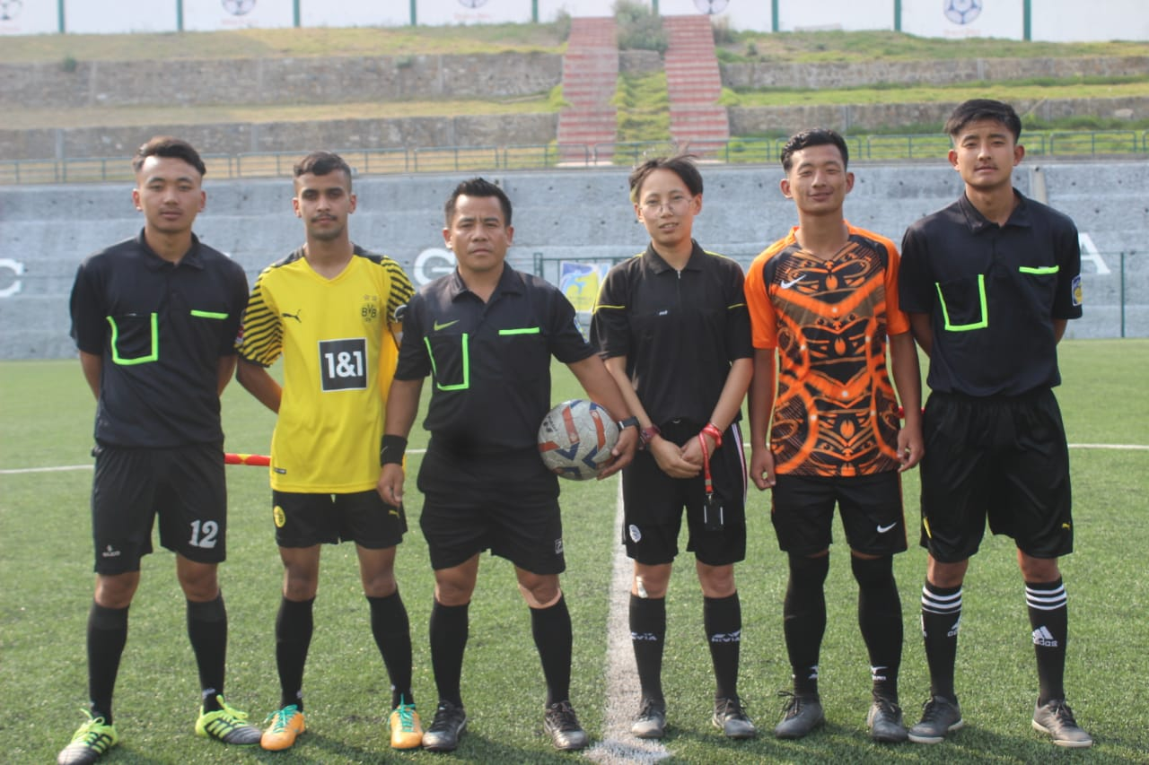
Figure 2: Referees and team captain of EHS and Physical Education

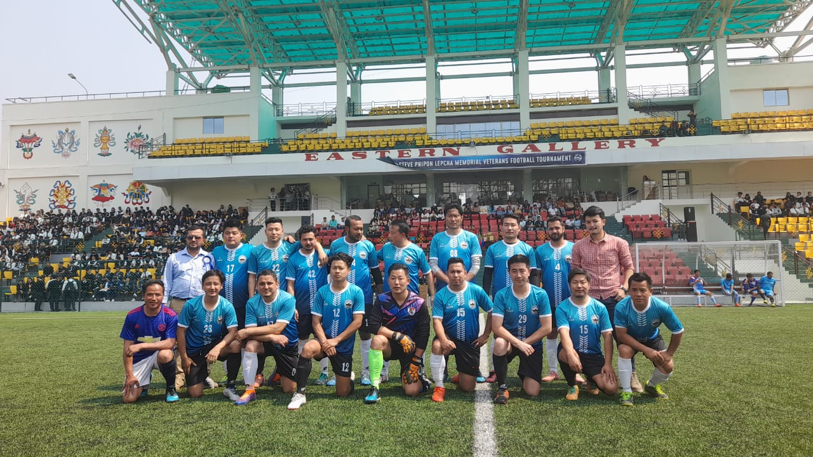
Figure 3: SGC, Namchi Staff Team.

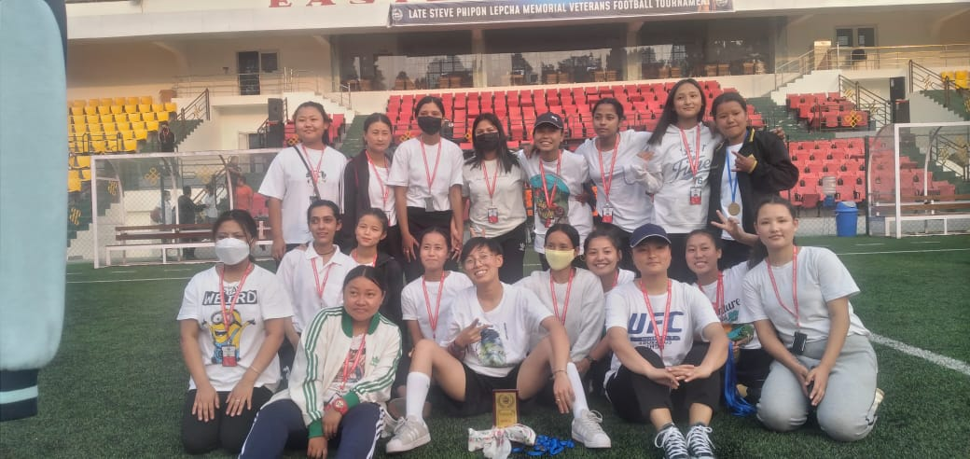
Figure 4: Physical Education Girls Team.

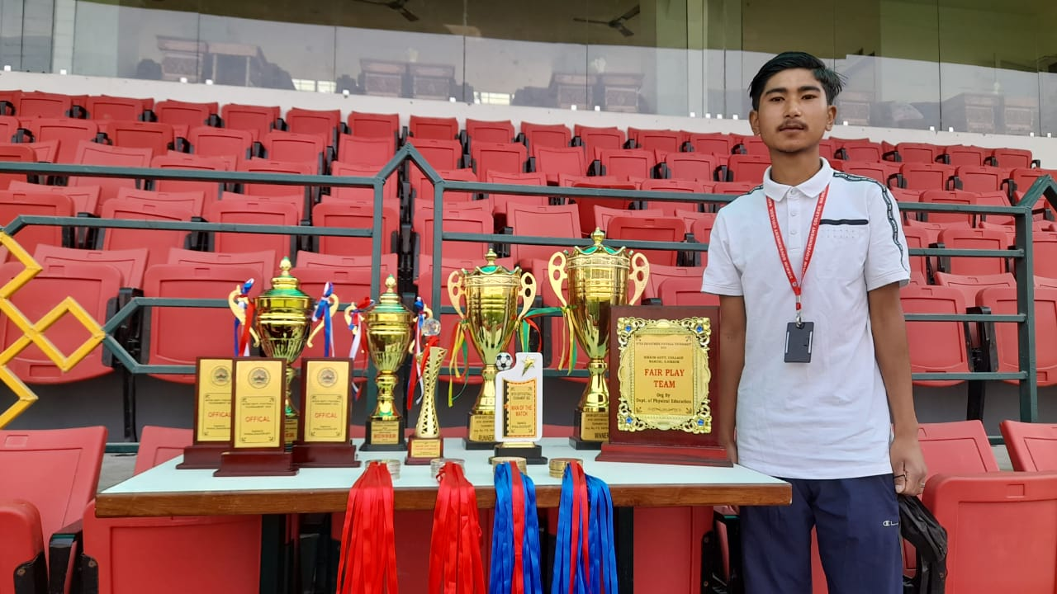
Figure 5: Trophies and mementos.

THE UNITY RUN ORGANISED BY NCC OF SIKKIM AND DARJEELING
(25TH MARCH, 2023)

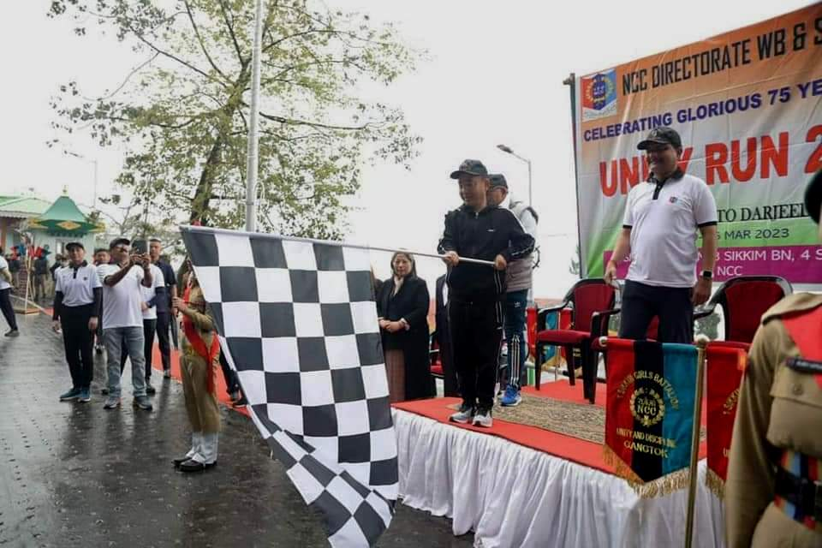

On the auspicious occasion of the 75 glorious years of NCC, the Unity Run was organised by NCC of Sikkim and Darjeeling Group Headquarter NCC. The run was flag off by Honourable Chief Minister of Sikkim Shri. P.S.Tamang at Mintokgang, Gangtok. The run was started from Gangtok and finished at Melli. Cadets from all the three battalion i.e., 1st Sikkim Girls Battalion, 3 Sikkim NCC Battalion and 4 Sikkim NCC Battalion had participated in this event. Total 24 cadets along with CTO Dr.Bikash Sharma of Sikkim Government College Namchi took part in Unity Run.

Annual Inter-Departmental Football Tournament
(17th – 28th April, 2023)
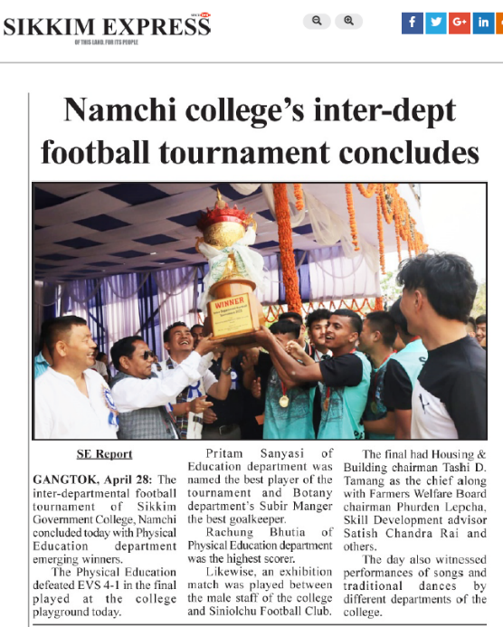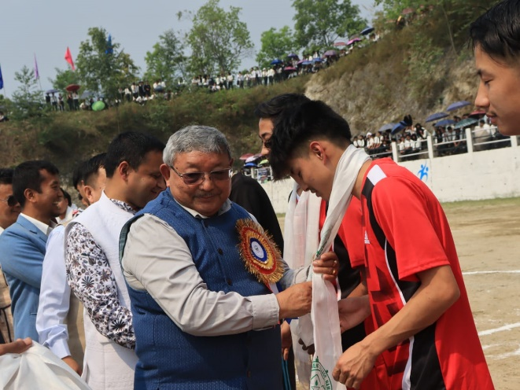
The annual inter-departmental football tournament at Sikkim Government College, Namchi was organized during the month of April 2023. The 12-day-long football tournament was inaugurated by Education Minister Shri. KungaNimaLepcha, Government of Sikkim on 17th April and concluded on 28th of April 2023. The inaugural ceremony was also attended by the Principal, Dr. Deepak Tiwari, teaching faculties, non-teaching staff of the college, students, and other guests. The Event was started by offering bouquets and khadas to the guests by the principal and lighting the ceremonial lamp.
Chief guest Shri. Lepcha in his address stressed on the importance of sports in a student’s life. He iterated that sports helps in developing perseverance, training, and motivation. He also stated that participation in sports is more important than its results, and hence he appealed all the students to concentrate on participation rather than its end results. Minister informed the gathering about the various initiatives of the state government to help its young folks by improving the quality of education in Sikkim. He informed that the state government has given the topmost priority to the education and health sector and striving towards achieving greater heights in the field of education. He mentioned the initiatives such as; free excursions to different places of India so that the students gain knowledge and ideas from other states too. At the end, he wished the students for progress, goodwill, and success in their lives.
Minister also inspected the newly constructed science building and other infrastructures in the college and interacted with the teachers and students of the college and listened to their grievances and demands for the betterment of the college.
In his welcome address, Principal, Dr. Tiwari encouraged the participation of all the students in sports. He highlighted the indispensable role that sports play in one’s lives, especially the students in maintaining good health. He further added that sports help in achieving their goal as it helps in focusing on a goal and teaches discipline.
In the inaugural football match the Department of English emerged victorious against the Department of Lepcha. During the entire 12 days tournament total of 27 teams from all the departments including teaching and non-teaching teams participated. Two to three matches were played each day and all the matches were played as a knock out games.
After completion of all the knockout matches final was played between the department of Physical Education and EVS on the concluding day of the tournament. The conclusion of the tournament executed in an extravagant manner with several local invited guests, dean, vice-principal, teaching and non-teaching staffs of the college, students witnessing the dance performances by different departments along with the final match and exhibition match played between staffs of college and veterans of Siniolchu Football Club, Namchi wherein college staff was defeated by SFC with 4-1 goals.
The chief guest of the day was Tashi D. Tamang, chairman of Housing & Building, GOS, along with PhurdenLepcha, Chairman, Farmers Welfare Board, Satish Chandra Rai, Advisor, Skill Development, GOS, among others.
Maruni dance was performed by the department of Physical Education, Gurung dance was performed by Department of Journalism & Mass Communication, RaiSakela dance was performed by the department of English, Nepali dance by Sociology department, and TamangSelo by BSc. students.
In his address Mr. Satish Chandra Rai encouraged the students to free themselves from the addiction of harmful substances such as drugs, alcohol, tobaccos etc. Instead he appealed them to focus in games and sports.
In the final match, department of Physical Education emerged victorious against EVS with 4-1 goals. Apart from the winner and runner-up trophy the players has been awarded in other categories as well. Best player of the tournament was conferred to PritamSanyasi of Education department, best goalkeeper was awarded to Subir Manger from Botany Department, and highest scorer was RachungBhutia of Physical Education.
Earlier in the day welcome speech was delivered by Dr. Chewang Soma Bhutia, Assistant Professor, PE department. Vote of thanks was delivered by the student President Mr. PadamGurung wherein he expressed his gratitude towards all the people including, teachers, guests, students and players for their utmost cooperation and help extended for the successful completion of the entire event.

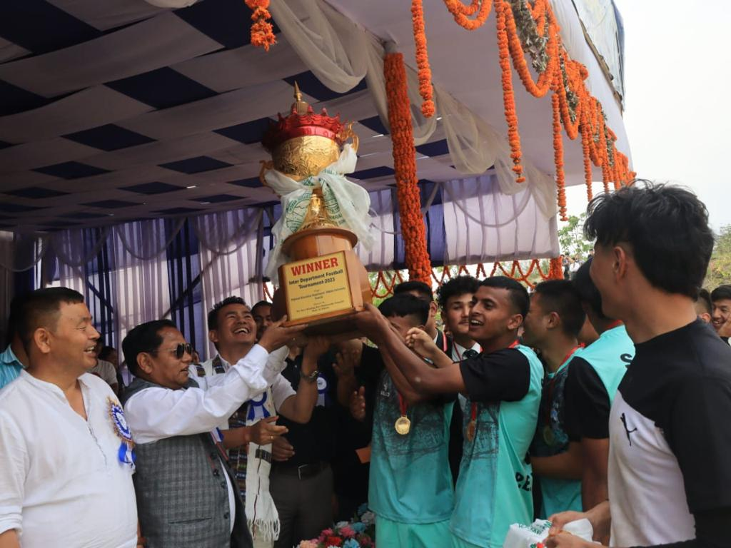
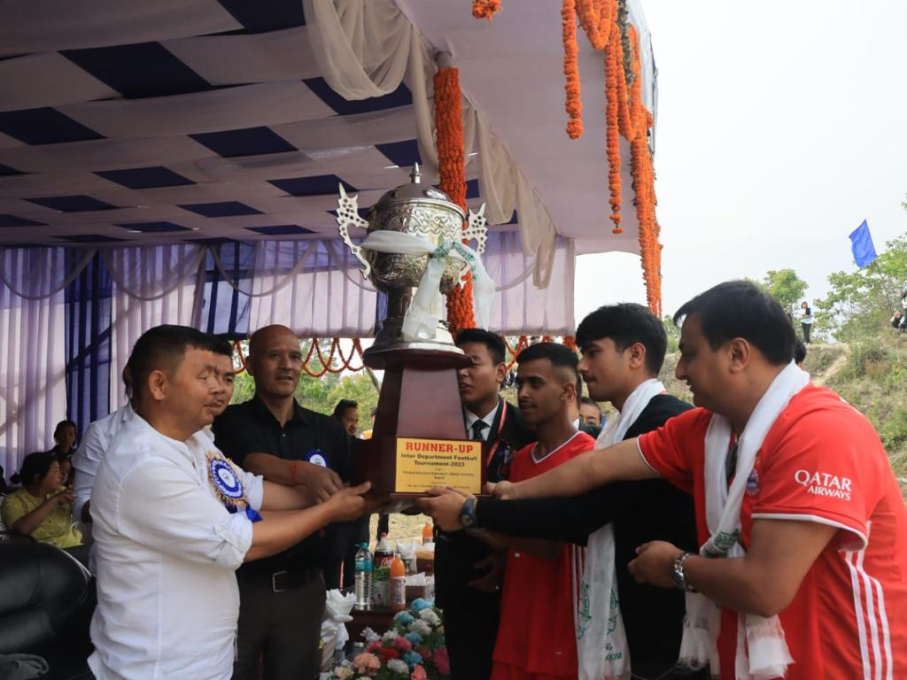
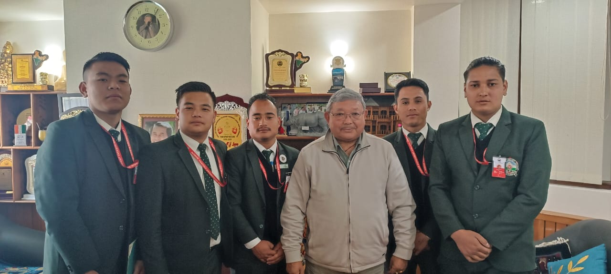

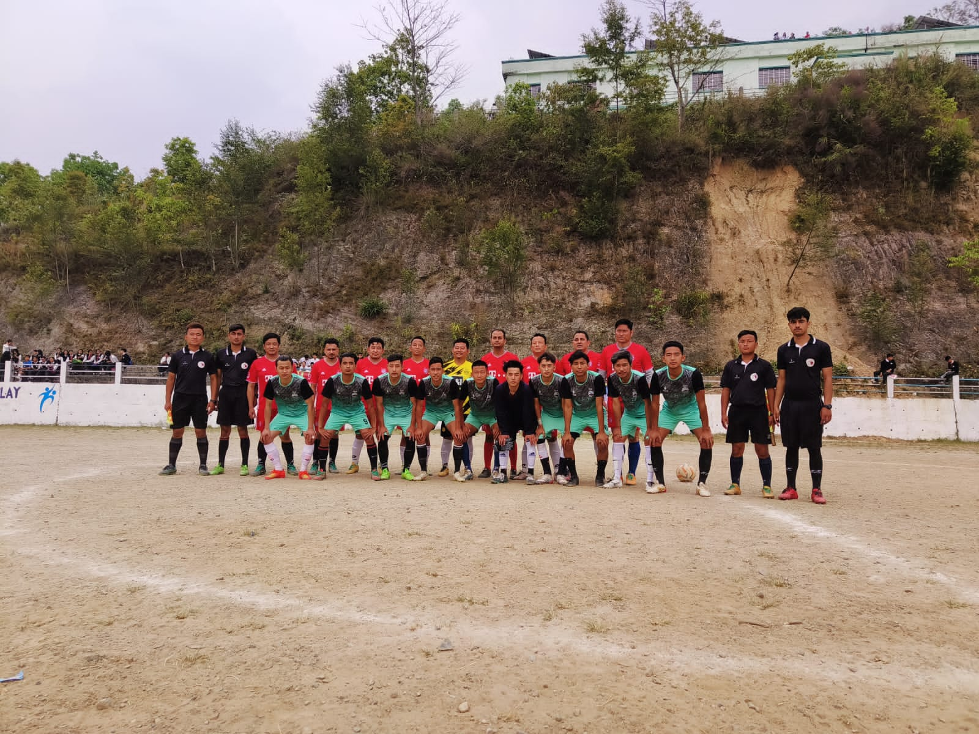

Sikkim Government College Namchi
Department of Physical Education
Report
Program Name: Ablaze Fest
Event: Inter-Collegiate Volleyball Tournament
Category: College Boys
Dated: 23rd May-25th May 2023
Venue: ICFAI University, Sikkim

The ICFAI University 0rganised Ablaze Fest from 22nd May to 25th May 2023 wherein Sikkim Government College, Namchi Participated in inter-collegiate volleyball tournament which was being schedule from 23rd May-25th May 2023. The total of 9 colleges took part in this event. The final of the tournament was graced by ADGP AkshaySachdeva and Vice Chancellor of ICFAI University. The final was played between SGC, Namchi and NBBDC, Gangtok wherein SGC Namchi won the tournament. The players were awarded with trophies and certificates and also Mr. Arpan Rai was awarded with man of the match award.

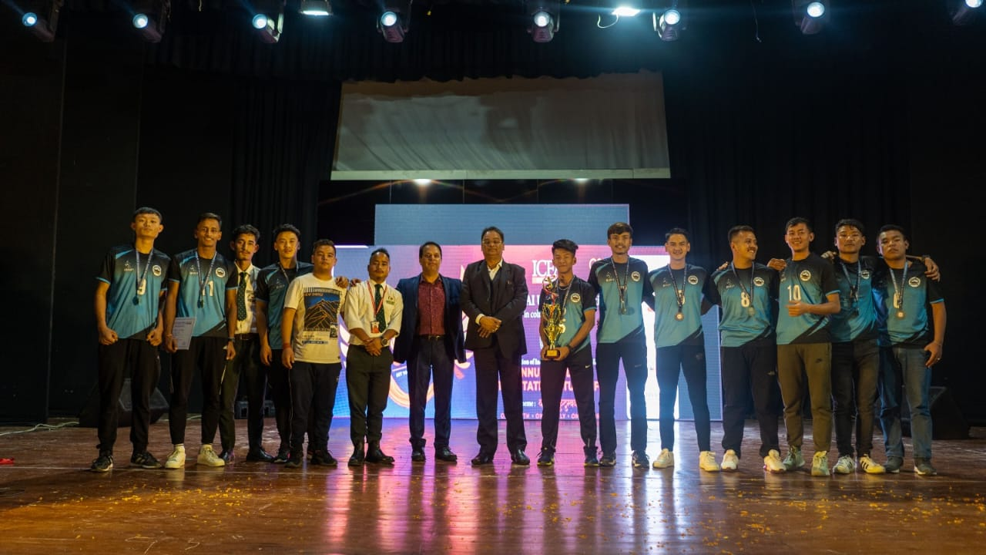
Figure 1: The players of SGC Namchi with the winning trophy and medals.

SIKKIM GOVERNMENT COLLEGE, NAMCHI SOUTH SIKKIM-737126

5.3.3 Number of sportsand cultural events/competitions in which students of the Institution participated during the year (organized by the institutions/other institutions)

College organized and participated on the following sports activities like football, Table Tennis, volleyball, Unity Run, on the following subsequent years.

Team Shakespeare Macbeth performed by English Department, SGC, Namchi
(2019-2022)

In a notable manifestation of cultural and literary reverence, the students of the English Department, Sikkim Government College Namchi embarked upon a remarkable journey into the world of Shakespearean drama. This theatrical endeavor took the form of a poignant enactment of "Macbeth," one of the enduring classics penned by the bard himself. This thespian feat unfolded on the significant date of the 31st of August in the year 2019. The performance was emblematic not only of the students' adeptness in language and dramatic presentation but also of their commitment to artistic expression.

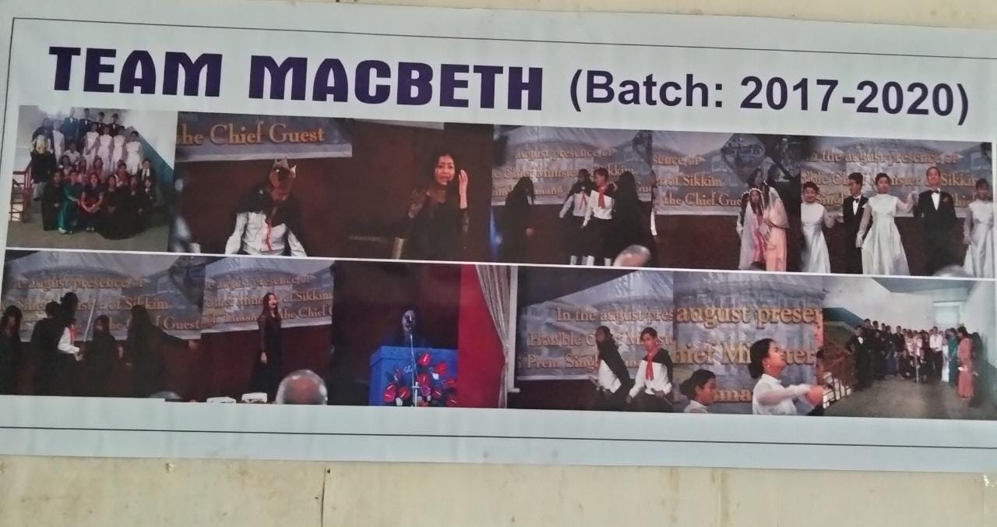
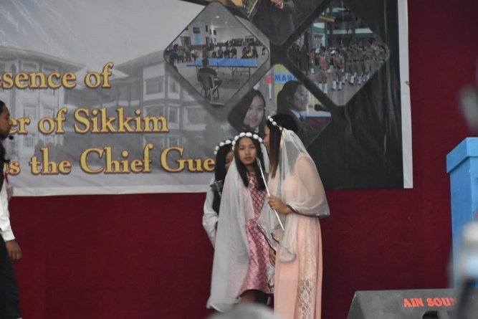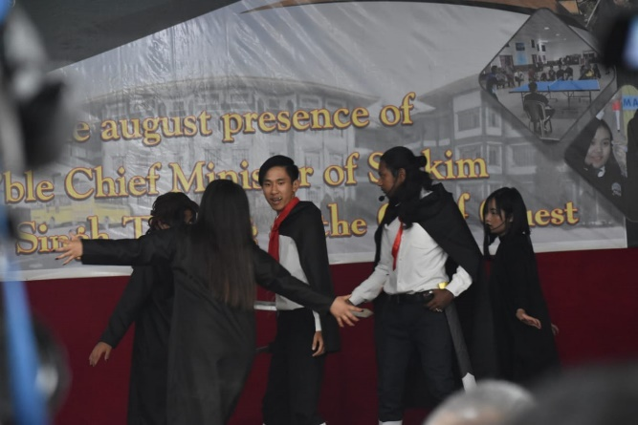
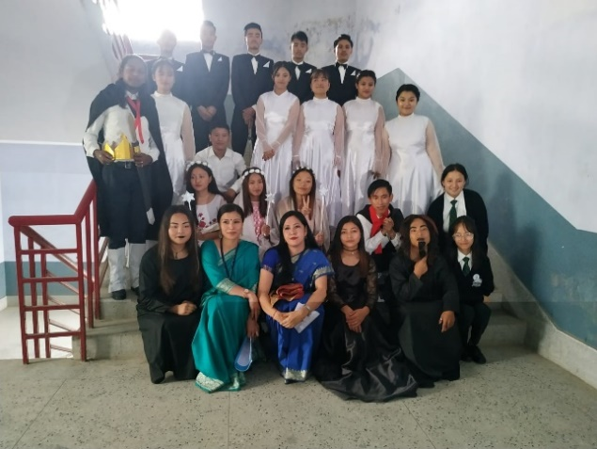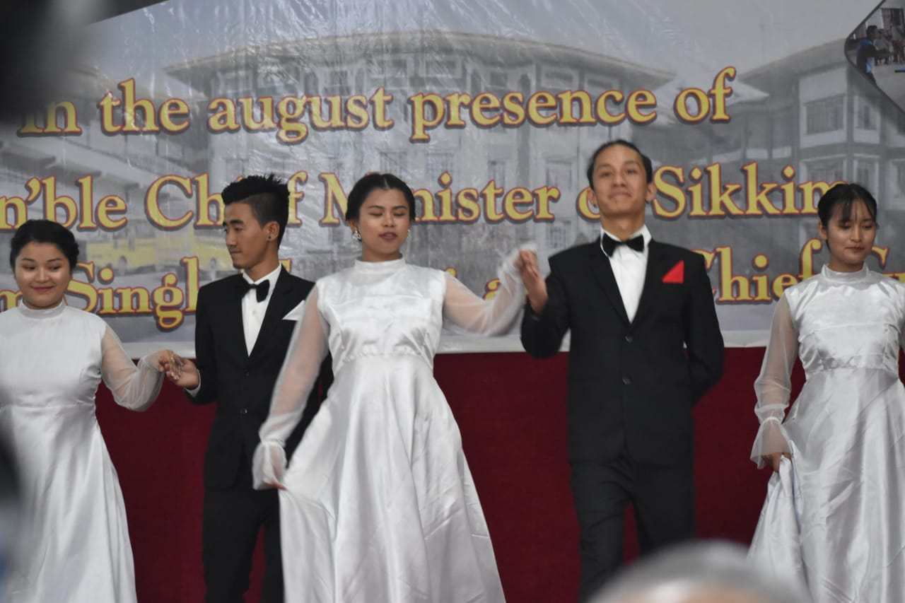

The occasion was further graced by the esteemed presence of the honorable Chief Minister of Sikkim, Prem Singh Golay. His presence resonated as a testament to the event's stature and to the symbiotic relationship between cultural expression and governance. The Chief Minister's attendance not only highlighted the college's cultural vitality but also signified his recognition of the role that academia and the arts play in the overall growth of a society.
The students' rendition of "Macbeth" was a masterful amalgamation of linguistic finesse and dramatic prowess. The play's intricate themes, complex characters, and poetic dialogues were brought to life on the stage, captivating the audience and transporting them to the world of medieval Scotland. The students' dedication to their roles, their meticulous attention to detail, and their adept delivery underscored their earnest commitment to both theatrical artistry and the literary legacy of Shakespeare.
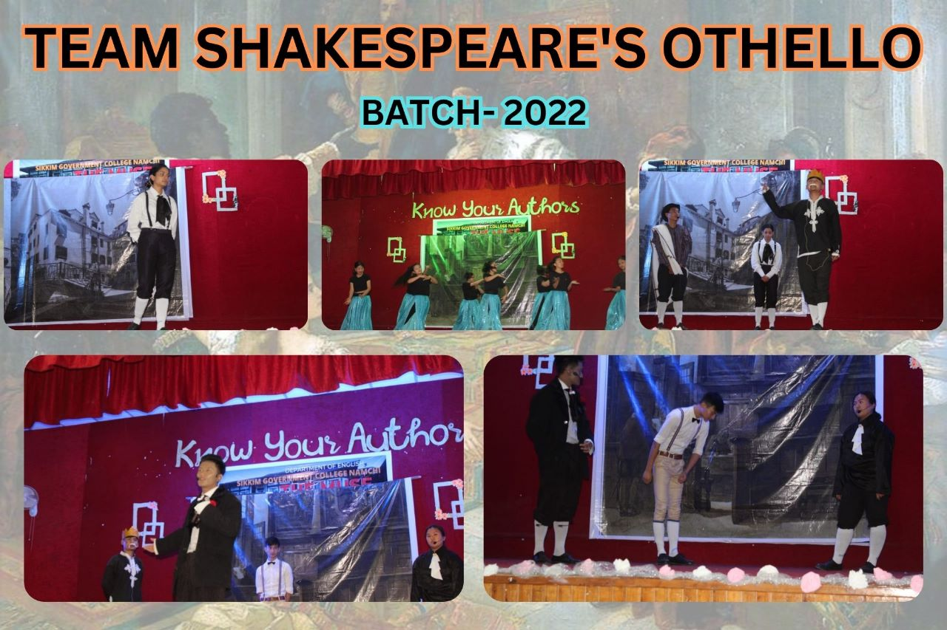

@ Sikkim New, 2022
English Department of Sikkim Government college Namchi organized an enactment on ‘Othello’ by William Shakespeare, along with open mic poetry presentations by students and interaction with local writers: PankajGiri (The Fragile Thread of Hope), SatyadeepChettri (Gorakha land Diaries), and senior reporter Namo Dixit, in the auditorium hall of the college.
In conclusion, the enactment of Shakespeare's "Macbeth" by the students of the English Department stands as a vivid testament to the college's academic and cultural vibrancy. It demonstrated a synergy between artistic expression and intellectual growth, encapsulating the essence of the institution's Silver Jubilee celebration. The presence of the honorable Chief Minister further emphasized the significance of the event, underscoring the role of education and the arts in shaping the holistic development of society.

SIKKIM GOVERNMENT COLLEGE, NAMCHI INAUGURAL CEREMONY OF A MONTH LONG MULTI-DISCIPLINARY SEMINAR/WORKSHOP
(28th April – 27th May 2022)

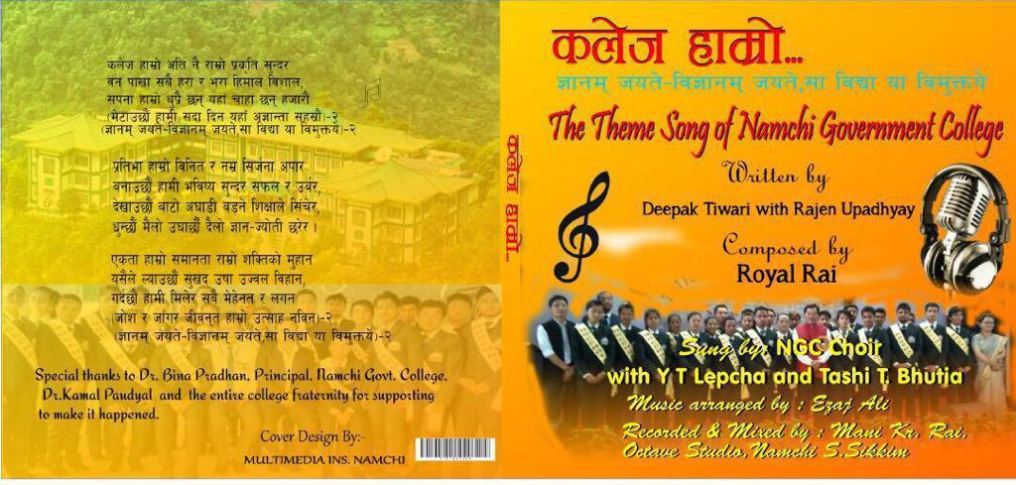
The Sikkim Government College Namchi orchestrated a captivating Multi-Disciplinary Seminar/Workshop from the 28th to the 27th of May 2022, within the esteemed confines of the college's auditorium hall. The event, graced by the esteemed presence of the chief guest, Shri Indra Hang Subba, a distinguished Member of Parliament hailing from the Government of Sikkim, marked a resounding convergence of intellectual pursuits. The occasion also bore witness to the eloquent insights shared by Mr. MP Subba, the Education Advisor to the Honorable Chief Minister of Sikkim. His erudition lent an enriching layer of intellectual discourse to the proceedings, accentuating the seminar's scholarly essence.

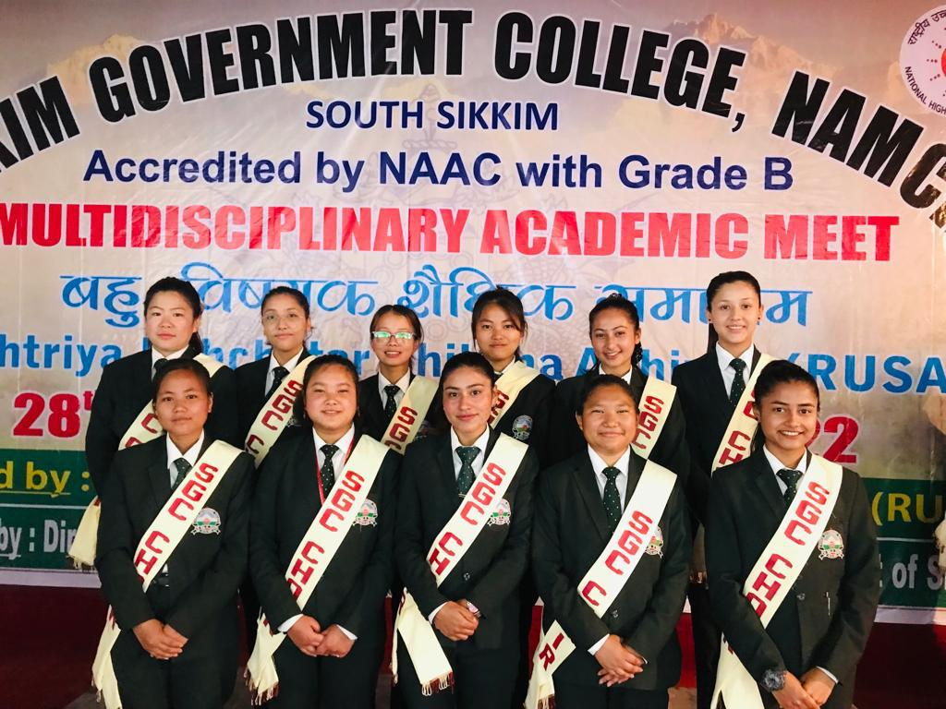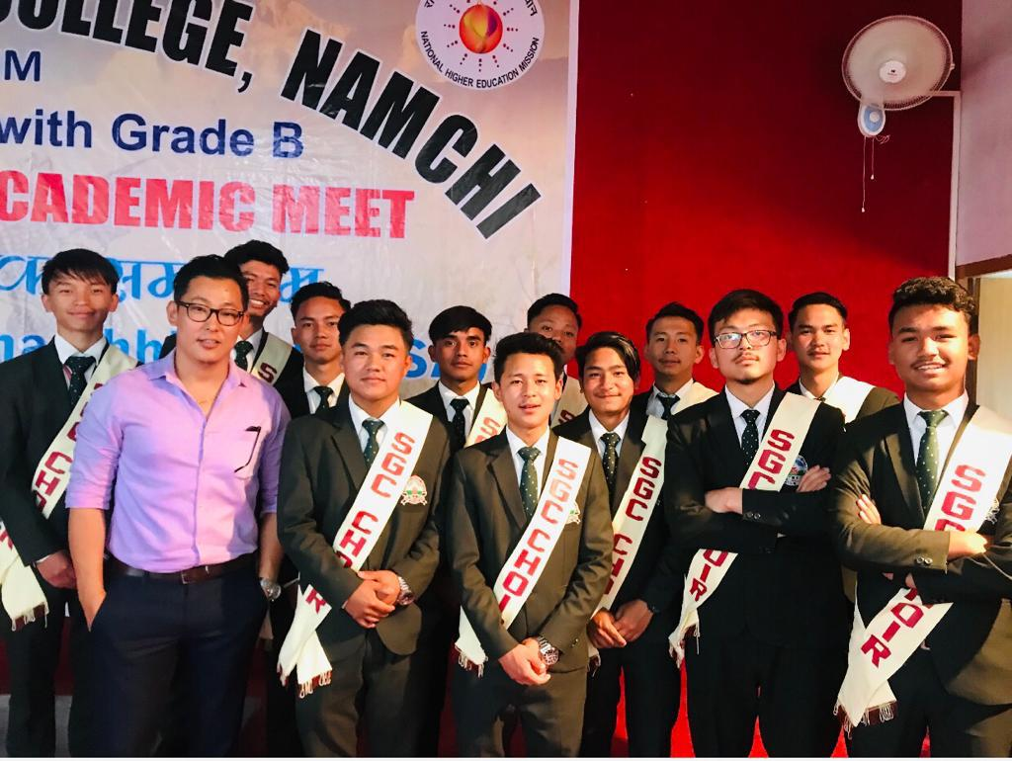
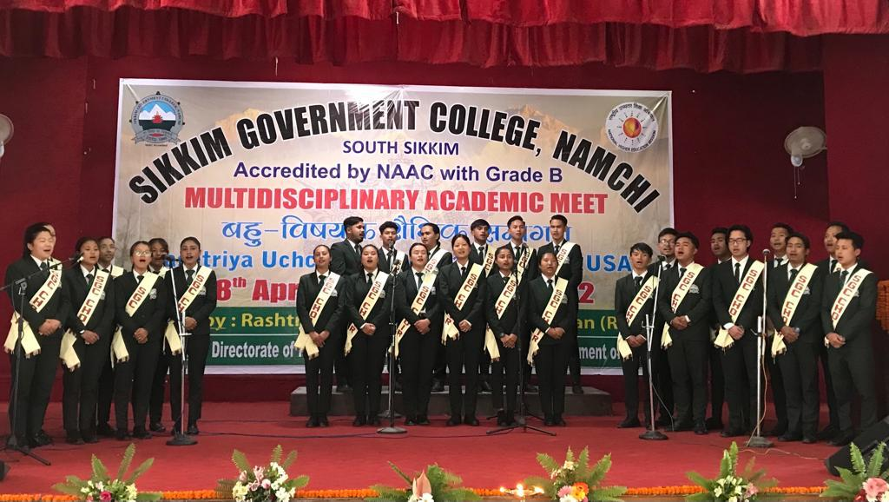
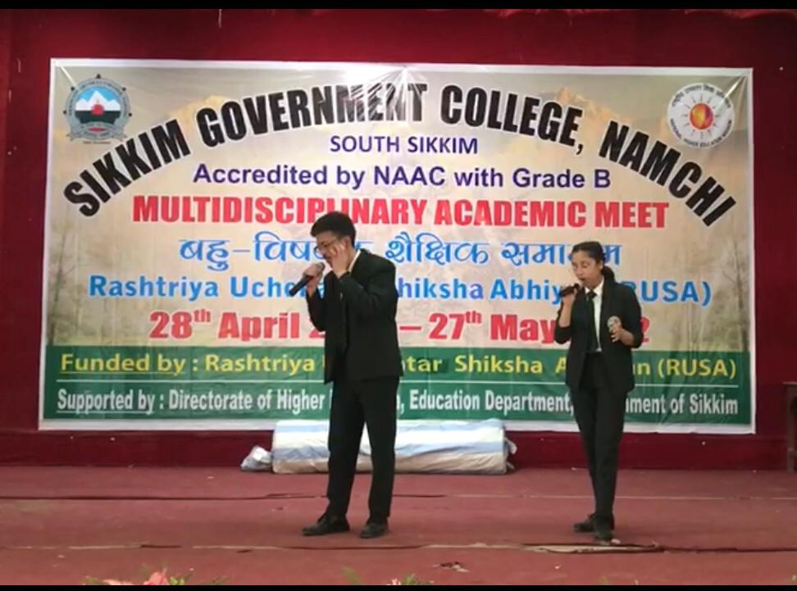

Undoubtedly, the heartening highlight of the event was the remarkable display of talent and enthusiasm by the students of Sikkim Government College. With an artistry that transcended mere performance, they presented a mosaic of cultural expressions that underscored their fervent dedication and ardent passion. The rendition of the College theme song, the harmonious duet singing, the soul-stirring choir presentation, and the vibrant collective dance were not just performances, but a testament to the students' dedication to their craft and their commitment to representing their institution with utmost finesse. It was palpably evident that the students had meticulously honed their skills, culminating in an enchanting and cohesive showcase that resonated with the audience. The exuberance and unity displayed in their performances attested to their disciplined approach and commendable teamwork.
In conclusion, the Multi-Disciplinary Seminar/Workshop held at Sikkim Government College Namchi illuminated the institution's commitment to fostering intellectual growth and cultural vibrancy. The students' outstanding performances served as a beacon of their passion, discipline, and united endeavor, further enriching the fabric of the event and affirming the college's stature as an esteemed center of learning and artistic expression.

“Read and Grow” Season-II Festive on 18-20 May, 2022

In a demonstration of both cultural acumen and commendable prowess, the students of Sikkim Government College, Namchi, actively engaged in the enriching sphere of intellectual and artistic pursuit. This participation took place during the auspicious occasion of the "Read and Grow" Season-2 Festive, meticulously orchestrated by the Sikkim KrantikariMorcha students' wing. The event unfolded within the distinguished precincts of the Manan Kendra, located in the picturesque city of Gangtok, and transpired over the dates spanning the 18th to the 20th of May in the year 2022.
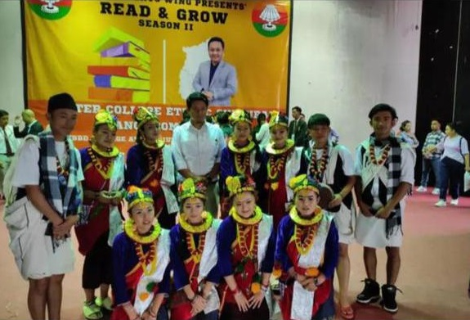
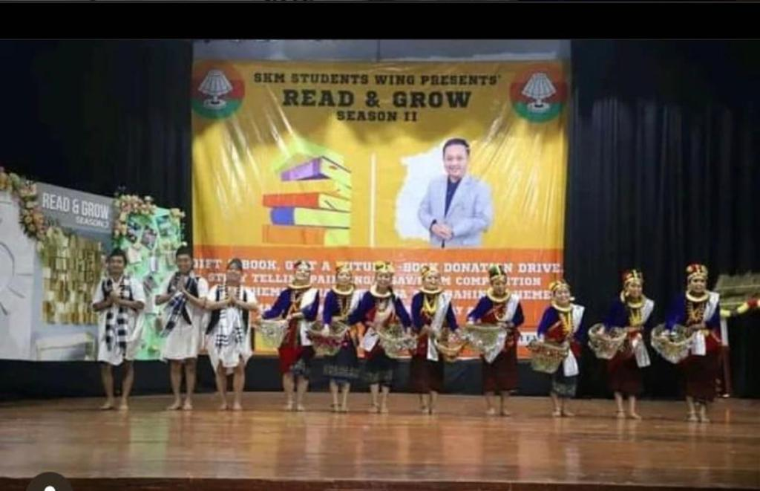
During this immersive endeavour, Sikkim Government College, Namchi, showcased a captivating and culturally resonant Nepali folk dance, specifically the revered GurungKauda dance. This particular dance form occupies a position of significance within the vibrant tapestry of the Gurung community's artistic heritage, which thrives within the geographical and cultural bounds of Sikkim. The graceful execution of this traditional dance unfolded as a tribute to the Gurung community's legacy and a testament to the students' dedication to preserving and propagating their cultural roots. The students' commitment to their craft was met with commendable recognition as they secured the esteemed second prize within the inter-college dance competition category. This triumph not only underscored their adeptness in mastering the intricacies of the GurungKauda dance but also attested to their collective determination and synchronized performance. The event's success is emblematic of the institution's dedication to fostering a holistic education that extends beyond the conventional realms of academia. It serves as a beacon illuminating the college's profound commitment to nurturing well-rounded individuals who are equipped with both intellectual acuity and artistic finesse.
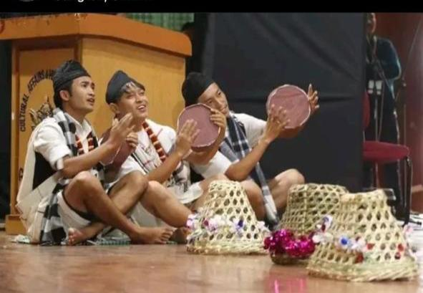
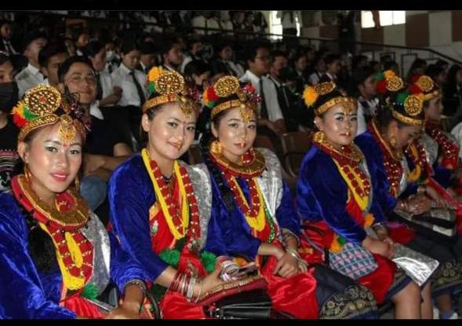

In summation, the participation of the Sikkim Government College, Namchi, in the "Read and Grow" Season-2 Festive stands as a tribute to the institution's cultural valor and academic fervor. The students' adept Nepali folk dance performance serves as a testament to their dedication and cultural affinity, leading to a noteworthy achievement in the inter-college dance competition. This endeavor exemplifies the institution's mission to nurture individuals who are not only academically adept but also actively engaged in preserving and perpetuating the rich cultural heritage of their community and region.

SIKKIM ART AND LITERATURE FESTIVAL 2023
YUKSOM, NORTH SIKKIM

The Sikkim Art and Literature Festival 2023, a confluence of intellectual and cultural significance, eloquently celebrated not only the literary tapestry of the region but also underscored the profound cultural and ethnic importance that the state of Sikkim embodies. Situated within the picturesque confines of Yuksom, North Sikkim, this seminal event unfolded from the 6th of May, extending its impactful influence throughout the year. This occasion, an eloquent testimony to the state's commitment to fostering artistic and literary endeavors, was set against the backdrop of Sikkim's rich tapestry of cultures, languages, and traditions. As a hallowed ground where diverse ethnicities seamlessly coalesce, Sikkim stands as a microcosm of India's cultural amalgamation, a facet that was earnestly celebrated through the festival's diverse offerings.
The gathering showcased luminaries such as AnandNeelkantan, Anuja Chauhan, Shobhaa De, and AnkushSaikia, whose literary prowess transcends geographical confines. Furthermore, the presence of distinguished personalities like the United Nations' Resident Coordinator for India, Shombi Sharp, lent a global perspective to the proceedings, accentuating the festival's commitment to addressing not only regional but also broader societal concerns. A particularly noteworthy inclusion was the esteemed child mental health expert, Amit Sen, whose participation underscored the festival's conscious endeavor to engage with pertinent issues spanning beyond the realms of literature and culture. This convergence of literary giants and accomplished experts marked the festival as a platform not just for literary indulgence, but also for nuanced discussions on matters of profound relevance.
In summary, the Sikkim Art and Literature Festival 2023, while exalting the literary heritage of the region, resounded with the resonances of Sikkim's cultural and ethnic richness. It stood as a beacon, illuminating the state's vital position within the cultural mosaic of the nation and its unwavering dedication to fostering both artistic expression and intellectual discourse.
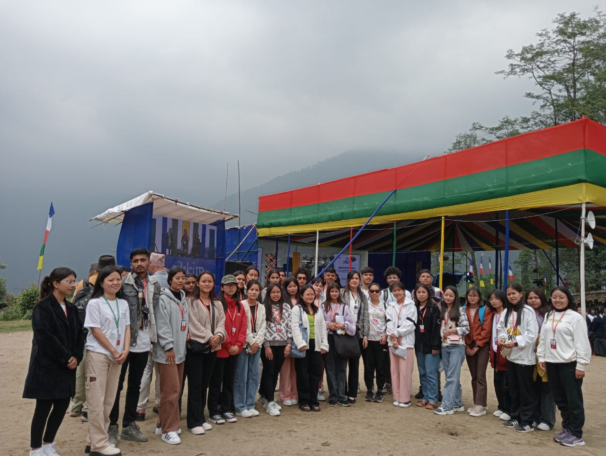
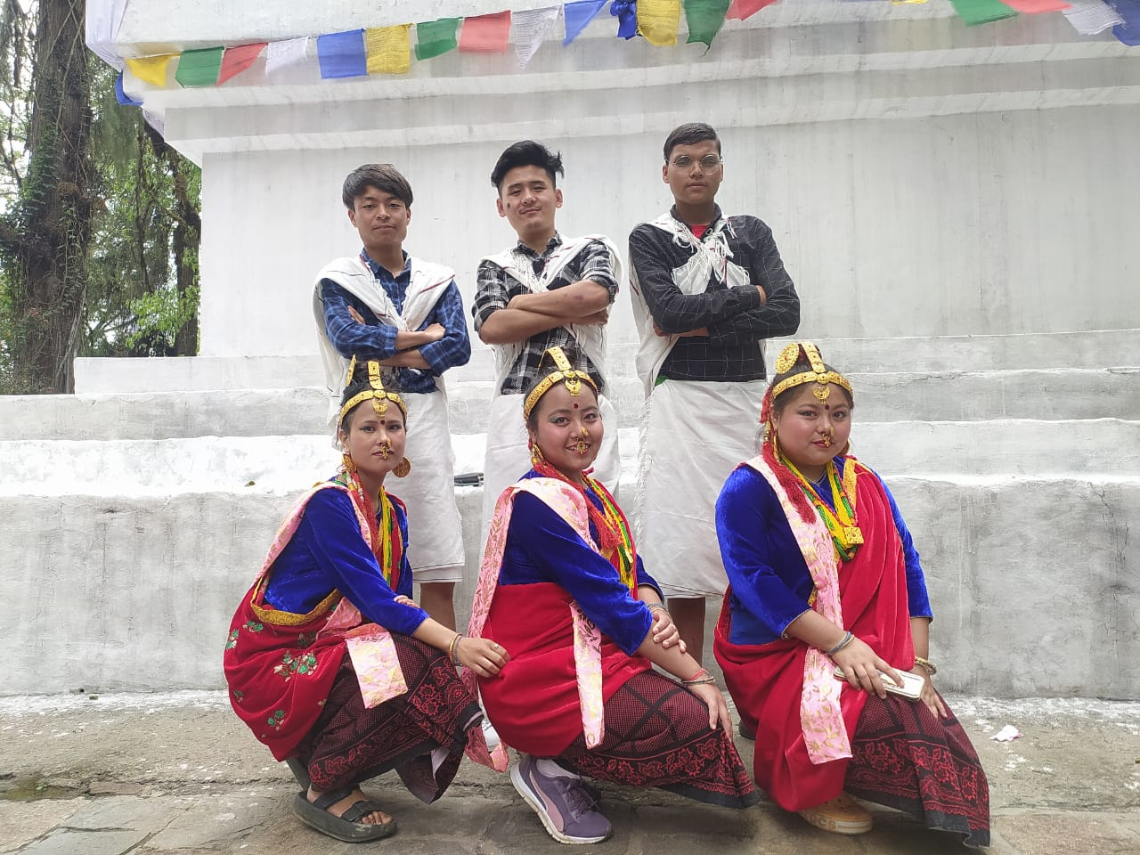
SGC Namchi students from English and Nepali department performed Nepali dance at Sikkim Art and Literature Festival 2023

STATE LEVEL TENDONG LHO RUM FAAT CELEBRATION 2023

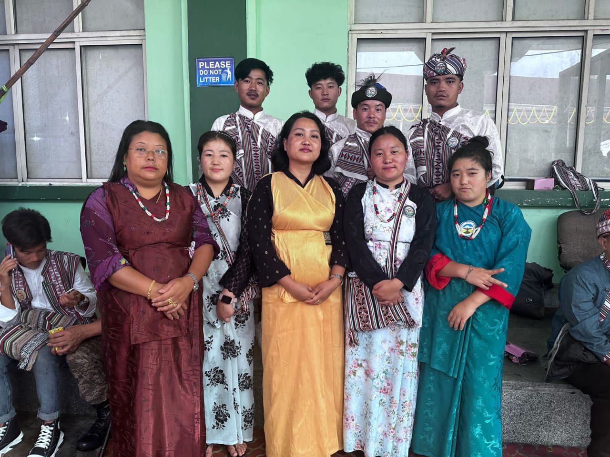

On the 7th and 8th of August 2023, a resplendent tapestry of cultural and literary fervor was woven as students from Sikkim Government College Namchi (Department of Lepcha) wholeheartedly engaged in an enriching celebration. This vibrant participation unfurled against the backdrop of the State Level TendongLho Rum Faat celebration for the year 2023, an event thoughtfully orchestrated by the TendongLho Rum Faat Celebration Committee. The esteemed venue of MananBhawan, nestled in the heart of Gangtok, East Sikkim, provided a fitting setting for this cultural rendezvous.
During these two days of exuberance, the students showcased their active involvement in a plethora of cultural and literary competitions, reflecting their profound affinity for their heritage and their unwavering dedication to expressing it through intellectual pursuits.
Amidst this spirited engagement, a notable achievement surfaced as NimalamoLepcha, a fifth-semester student, clinched the prestigious third position in the essay writing competition. This feat is not merely a testament to the student's eloquence in the written word but also serves as an embodiment of the collective commitment demonstrated by the entire Lepcha Department.
Beyond the realm of competitions, the students enjoyed a privileged opportunity to partake in a diverse array of cultural events that unfurled over the course of these two splendid days. These events formed a vibrant mosaic of cultural expressions, traditions, and customs, enriching their understanding of their own heritage and fostering a sense of camaraderie.

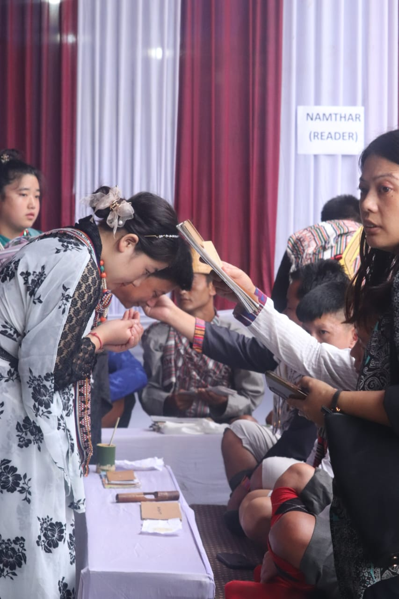

DEPARTMENT OF LEPCHA AND LIMBOO PARTICIPATED IN FOLK DANCE COMPETITION ON 43rd FOUNDATION DAY SIRIJUNGA 2023

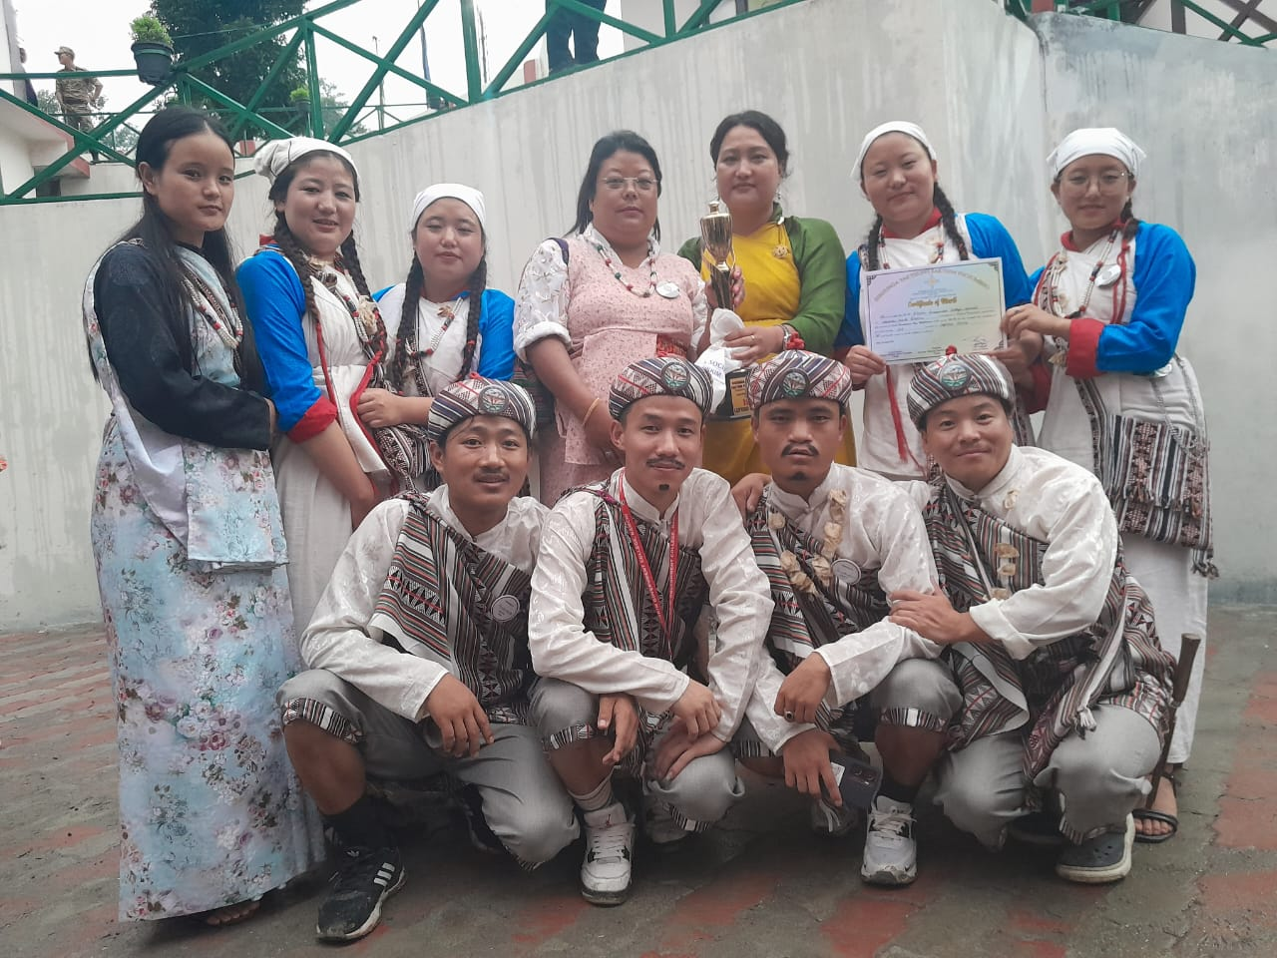

On 22nd and 23rd August 2023, the resonating echoes of cultural celebration reverberated as Sikkim Government College Namchi proudly took part in cultural dance competition. Students hailing from the Lepcha and Limboo department united in a vibrant tapestry of participation, representing their heritage in a captivating folk dance competition. This cultural rendezvous was an integral part of the 43rd Foundation Day festivities hosted during SirijungaYakthungSaktimPhoojumbho, which was organized by the Limboo Cultural Society of Tharpu region in West Sikkim. The students embarked on this creative journey under the guidance of their dedicated teachers, Miss NimkitLepcha and Ms.DilluHangmaSubba.
The Lepcha folk dance performance, a reverent tribute to tradition, emerged triumphant by securing the prestigious first position in the main competition. This success mirrors the students' ardent dedication to preserving their cultural legacy and presenting it with artistic finesse. Simultaneously, the Limboo folk dance resonated with its own distinct vibrancy, securing a noteworthy third position in the dedicated Limboo folk dance competition. This accomplishment not only added another laurel to the college's achievements but also further reinforced the students' role as cultural torchbearers.
In retrospection, the dates of 22nd and 23rd August 2023 shine brightly as a testament to the enriching cultural spirit of Sikkim Government College. The students' representation and participation in the folk dance competition during the 43rd Foundation Day celebrations of SirijungaYakthungSaktimPhoojumbho echo the institution's commitment to fostering cultural awareness and appreciation. The remarkable victory of the Lepcha folk dance, coupled with the commendable recognition of the Limboo folk dance, underscore the profound dedication of the students and the college's pivotal role in nurturing cultural heritage and mutual understanding.

