SIKKIM GOVERNMENT COLLEGE, NAMCHI
NAMCHI SOUTH SIKKIM, PIN: 737126
NAAC ACCREDITED (UGC 2F & 12B) ESTD:1995
SUPPORTING DOCUMENT
- Event: Guidance for Competitive Exam
Event Date: 29/11/2021
EVENT DESCRIPTION
The North Eastern Chapter of EIRC of ICSI, in collaboration with Sikkim Government College Namchi's Department of Commerce, organized an Online Career Awareness Programme, shedding light on ICSI courses, the role of a Company Secretary, and competitive exams like CA. This initiative equips commerce students with vital information for making informed career choices and highlights the importance of the Company Secretary profession in today's changing economic landscape.

EVENT PHOTOGRAPHS

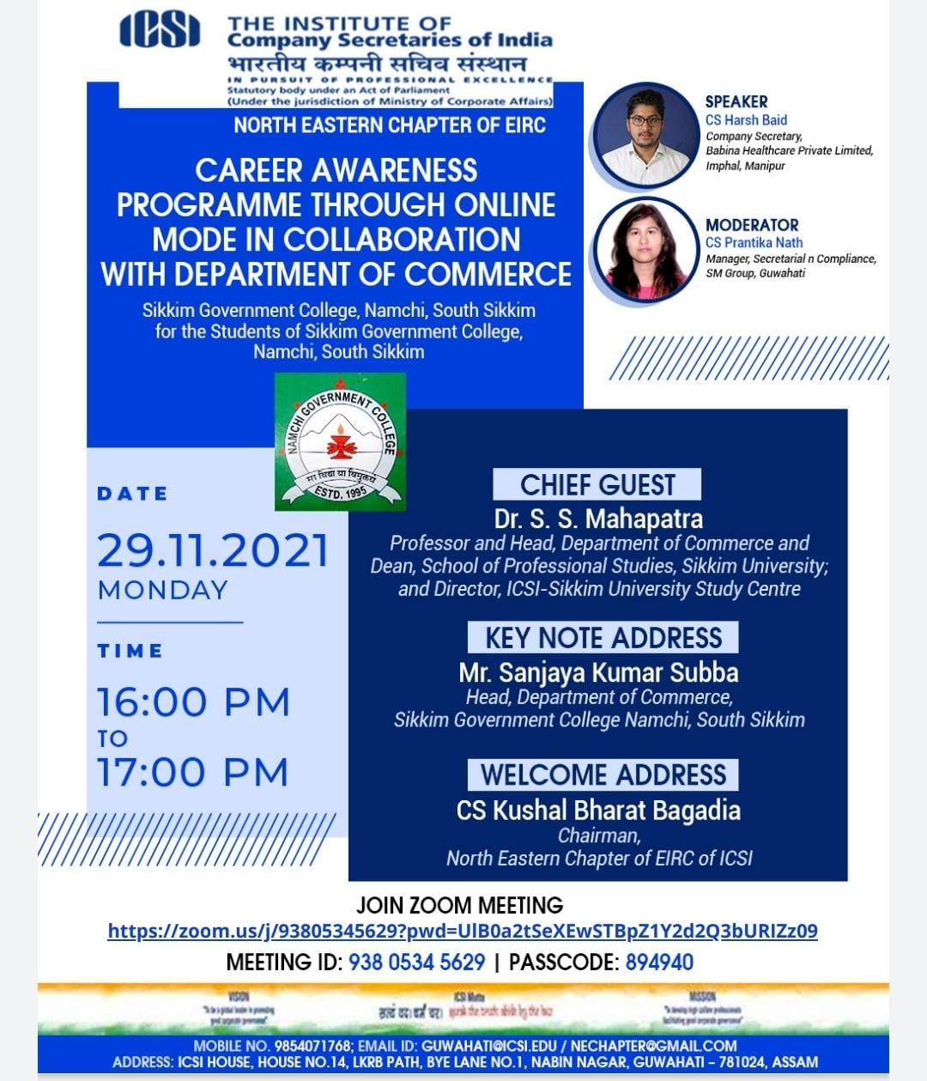

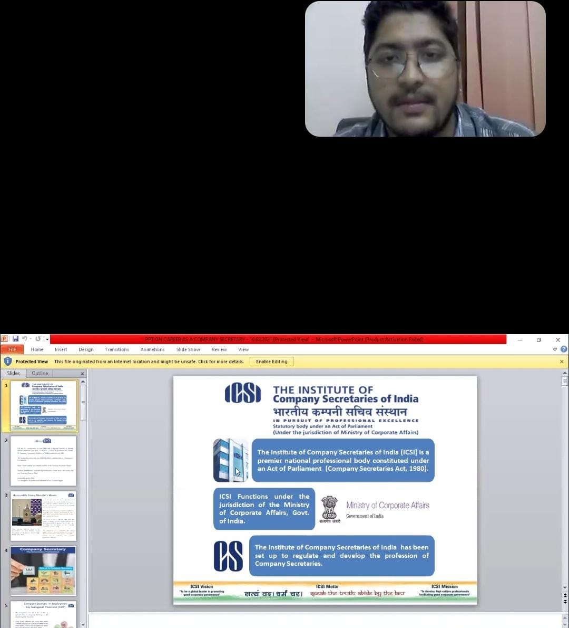
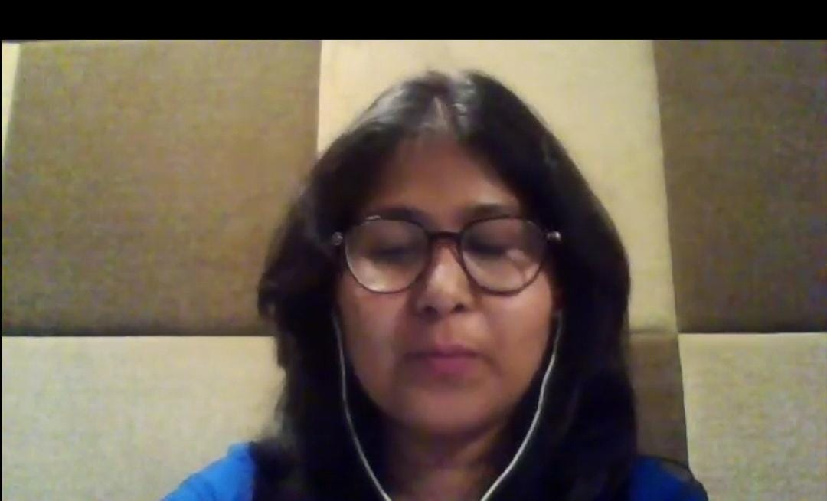


- Event: Career Counseling
Event Date: 30/05/2022
SGC Namchi, in association with Sikkim Manipal Institute of Technology, conducted a career counseling program on May 30, 2022. Dr. Bineth Sharma and Mr. Raj Kumar, Assistant Professors, discussed various career options with sixth-semester students from B.A, B.Sc, and B.Com, aiding them in making informed choices for their future paths
EVENT DESCRIPTION
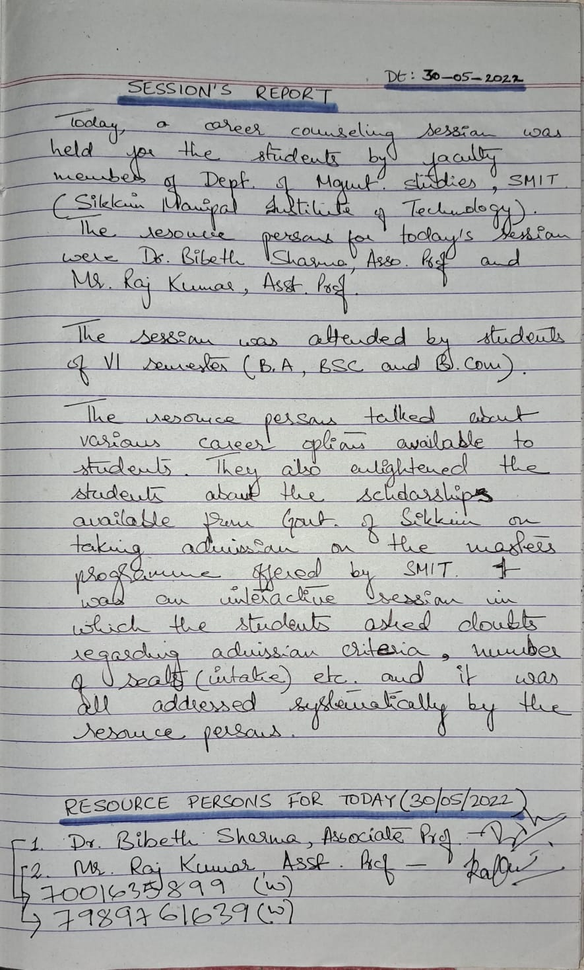
.

EVENT PHOTOGRAPHS
